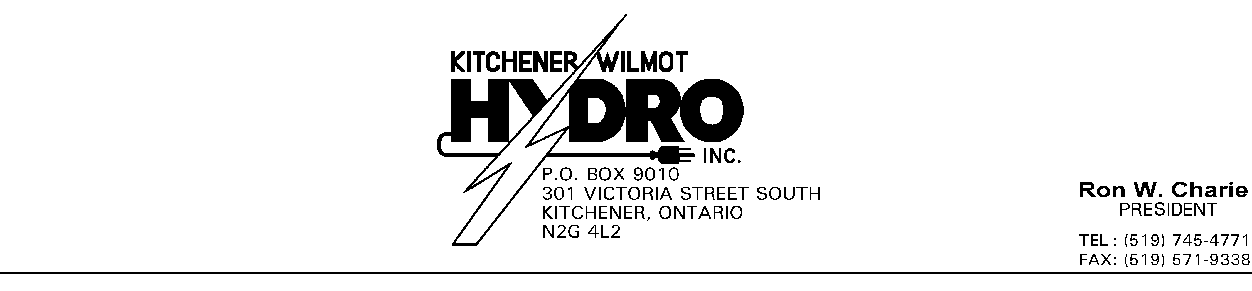

December 6, 2005

John Zych, Board Secretary
Ontario Energy Board
2300 Yonge Street, Suite 2700
P.O. Box 2319
Toronto, ON M4P 1E4

Re: RP-2005-0020/ED-2005-0529
Kitchener-Wilmot Hydro Inc.’s EB-2005-0386 response to VECC

Dear Mr. Zych:

Attached please find six hard copies and one electronic copy of Kitchener-Wilmot Hydro Inc.’s responses to interrogatories submitted by the Vulnerable Energy Consumers Coalition (VECC).

Sincerely,

R. Charie, B.Comm, C.G.A. President & CEO
Mn
Enclosure

cc: Michael Janigan, Counsel for VECC

