January 3, 2006

Via Courier and E-mail

Mr. John Zych
Ontario Energy Board
PO Box 2319, 27th Floor
2300 Yonge Street
Toronto ON M4P 1E4

Dear Mr. Zych:

Re: RP-2005-0020, 2006 EDR Rate Application Generic Issues

Enclosed are 8 hard copies of Chatham-Kent Hydro Inc. submission on the 2006 EDR Rate Application, Generic Issues. I have also e-mailed an electronic copy to the Board Secretary at Boardsec@oeb.gov.on.ca.

Thank you.

Yours truly,

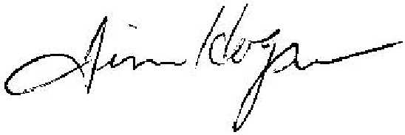
Jim Hogan
Chief Financial and Regulatory Officer
Chatham-Kent Energy Inc.

