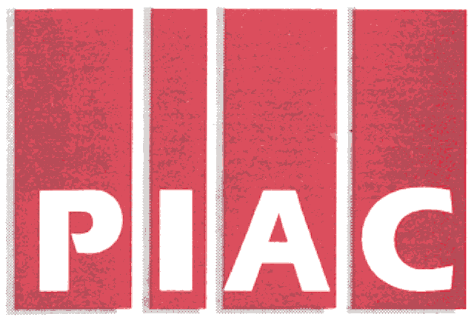November 15, 2005
PUBLIC INTEREST ADVOCACY CENTRE
LE CENTRE POUR LA DEFENSE DE L’INTERET PUBLIC

ONE Nicholas Street, Suite 1204, Ottawa, Ontario, Canada K1N 7B7
Tel: (613) 562-4002. Fax: (613) 562-0007. e-mail: piac@piac.ca. http://www.piac.ca

VIA Fax and E-MAIL
Mr. John Zych
Board Secretary
P.O. Box 2319
2300 Yonge St.
Toronto, ON
M4P 1E4

Dear Mr. Zych:

Re: RP-2005-0020 / EB-2005-0364
Festival Hydro Inc. – 2006 Electricity Distribution Rate Application
Interrogatories of Vulnerable Energy Consumers Coalition (VECC)

Please find enclosed the Interrogatories of the Vulnerable Energy Consumers Coalition (VECC) in the above-noted proceeding. We shall also be directing a copy of the same to the Applicant.

Thank you.

Yours truly,

Michael Janigan
Counsel for VECC

cc: Mr. William Zehr – Via Fax and Mail
Festival Hydro Inc.
Festival Hydro Inc.
2006 Rate Application RP-2005-0020/EB-2005-0364
Utility-Specific Interrogatories of the
Vulnerable Energy Consumers’ Coalition (VECC)

Question #1

Reference: General

- Please provide a hard copy of the Manager’s Summary and the Supporting Schedules. (Note: Neither is available in electronic form on the OEB’s web-site nor have copies been received in response to VECC’s Notice of Intervention)

Question #2

Reference: EDR 2006 Model, ADJ 3

- Please provide a detailed description of the C&DM program associated with the $9,000 reported under item #7, Tab ADJ 3 and the supporting TRC calculations.

Question #3

Reference: EDR 2006 Model, Tab 8-5

- Please provide a detailed explanation/rationale for the direct rate mitigation adjustments set out in this Tab for the Residential Class.

- The Direct Rate Mitigation appears to increase both the fixed and variable rates for Hensall. Please confirm that this is the case and explain why. Also, please explain where the offsetting revenue reduction is incorporated.

Question #4

Reference: EDR 2006 Model, Tab 9-1

- Please confirm that the total bill impact of the proposed rates on a Residential customer in the Hensall service area using 500 kWh / month is 11.46%.

- What percentage of the Hensall service area residential bills are for usage of 500 kWh per month or less.

- Did Festival consider any further options to mitigate the impact for these customers? If not, why not? If yes, what were the options considered and why were they rejected?

***End of Document***

