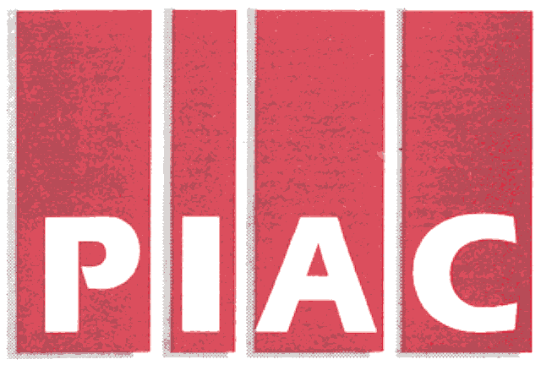November 15, 2005
PUBLIC INTEREST ADVOCACY CENTRE
LE CENTRE POUR LA DEFENSE DE L’INTERET PUBLIC

ONE Nicholas Street, Suite 1204, Ottawa, Ontario, Canada K1N 7B7
Tel: (613) 562-4002. Fax: (613) 562-0007. e-mail: piac@piac.ca. http://www.piac.ca

VIA Fax and E-MAIL
Mr. John Zych
Board Secretary
P.O. Box 2319
2300 Yonge St.
Toronto, ON
M4P 1E4

Dear Mr. Zych:

Re: RP-2005-0020 / EB-2005-0375 and 0376
Horizon Utilities Corporation
2006 Electricity Distribution Rate Application
Interrogatories of Vulnerable Energy Consumers Coalition (VECC)

Please find enclosed the Interrogatories of the Vulnerable Energy Consumers Coalition (VECC) in the above-noted proceeding. We shall also be directing a copy of the same to the Applicant.

Thank you.

Yours truly,

Original signed

Michael Janigan
Counsel for VECC

cc: Mr. Cameron McKenzie
Horizon Utilities Corporation

Mr. James Sidlofsky
Counsel
Horizon Utilities Corporation
2006 Rate Application RP-2005-0020/EB-2005-0375
Utility-Specific Interrogatories of the
Vulnerable Energy Consumers’ Coalition (VECC)

Question #1

Reference: Schedule 6-2
Schedule 3-2

- Please confirm that the net effect of the Tier 1 adjustment for Bad Debt expense results in Bad Debt Expense of $795,784 being included in Horizon’s Revenue Requirement. If this is not the case, please indicate what the ultimate value for Bad Debt Expense (i.e., after all adjustments) included for rate setting purposes is.

Question #2

Reference: Schedule 6-8

- Please provide more details regarding what is meant by “Full Cost-Based Pricing”. What cost elements and overheads are included and how it the level of activity determined?

- Has any third party review been conducted of Horizon’s costing methodology? If yes, please indicate by whom and provide a summary of their findings.

Question #3

Reference: Schedule 6-9

- With respect to the allocation of shared services from St. Catherines Hydro Inc.:
    - Please provide details as to the types of activities covered by the Management Fee,
    - Please indicate the other parties to whom St. Catherines Hydro Inc. allocates as share of the costs of these activities,
    - Are all of the costs incurred by St. Catherines Hydro Inc. for these activities allocated/charged out to affiliates? If not, how is portion to be retained by St. Chatherines Hydro Inc. determined?

- With respect to the allocation of shared services from Hamilton Utilities Corporation:
    - Please provide details as to the types of activities covered by the Management Fee,
    - Please indicate the other parties to whom Hamilton Utilities Corporation allocates as share of the costs of these activities,
    - Are all of the costs incurred by Hamilton Utilities Corporation for these activities allocated/charged out to affiliates? If not, how is portion to be retained by Hamilton Utilities Corporation determined?

***End of Document***

