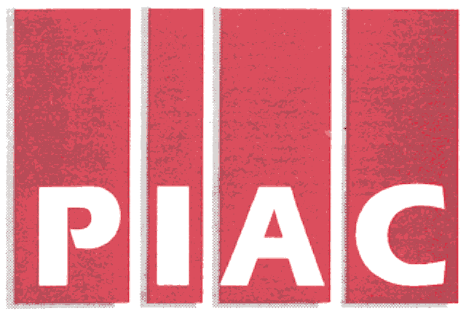
PUBLIC INTEREST ADVOCACY CENTRE
LE CENTRE POUR LA DEFENSE DE L’INTERET PUBLIC

ONE Nicholas Street, Suite 1204, Ottawa, Ontario, Canada K1N 7B7
Tel: (613) 562-4002. Fax: (613) 562-0007. e-mail: piac@piac.ca. http://www.piac.ca

November 15, 2005

VIA Fax and E-MAIL

Mr. John Zych
Board Secretary
P.O. Box 2319
2300 Yonge St.
Toronto, ON
M4P 1E4

Dear Mr. Zych:

Re: RP-2005-0020 / EB2005-0422
Veridian Connections Inc.
2006 Electricity Distribution Rate Application Interrogatories of Vulnerable Energy Consumers Coalition (VECC)

Please find enclosed the Interrogatories of the Vulnerable Energy Consumers Coalition (VECC) in the above-noted proceeding. We shall also be directing a copy of the same to the Applicant.

Thank you.

Yours truly,

Original Signed

Michael Janigan
Counsel for VECC

cc: Mr. George Armstrong - Veridian Connections Inc.
Veridian Connections Inc.
2006 Rate Application RP-2005-0020/EB-2005-0422
Utility-Specific Interrogatories of the
Vulnerable Energy Consumers’ Coalition (VECC)

Question #1

Reference: Summary of Application, page 18
EDR 2006 Model, Tab 3-4
Schedule 5-1

- Please indicate whether the Municipality of Clarington, the City of Pickering, the Town of Ajax or the City of Belleville were the owners of their respective electric distribution utilities at the time the debt owing to each was issued in 2001.

- Please indicate why none of these 4 municipalities are currently considered to be affiliates of Veridian, even though they hold shares in Veridian Corporation.

Question #2

Reference: Schedule 6-5

- Please confirm that all of the Employee Incentive Plan expense has been included as distribution costs for purposes of establishing the 2006 proposed rates.

- Of the $143,051 in incentive compensation paid in 2004, how much was related to the Net Income performance measure?

Question #3

Reference: Schedule 6-9

- Please describe how the “usage” by Veridian Connection Inc. of the various shared services is determined. For example, are time logs maintained by Veridian Corporation employees to determine the “hours” of service provided to the distribution utility?

- Please describe how the hourly charge rates are determined and what types of costs are included.

***End of Document***

