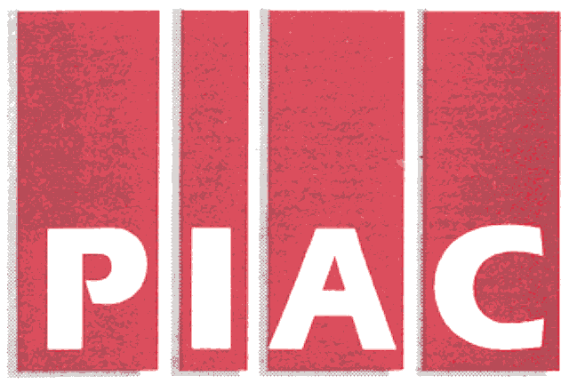
PUBLIC INTEREST ADVOCACY CENTRE
LE CENTRE POUR LA DEFENSE DE L’INTERET PUBLIC

ONE Nicholas Street, Suite 1204, Ottawa, Ontario, Canada K1N 7B7
Tel: (613) 562-4002. Fax: (613) 562-0007. e-mail: piac@piac.ca. http://www.piac.ca

November 15, 2005

VIA Fax and E-MAIL

Mr. John Zych
Board Secretary
P.O. Box 2319
2300 Yonge St.
Toronto, ON
M4P 1E4

Dear Mr. Zych:

Re: RP-2005-0020 / EB2005-0435 Whitby Hydro Electric Corporation
2006 Electricity Distribution Rate Application
Interrogatories of Vulnerable Energy Consumers Coalition (VECC)

Please find enclosed the Interrogatories of the Vulnerable Energy Consumers Coalition (VECC) in the above-noted proceeding. We shall also be directing a copy of the same to the Applicant.

Thank you.

Yours truly,

Michael Janigan
Counsel for VECC

cc: Ms. Ramona Abi-Rashed - Whitby Hydro Electric Corporation

Whitby Hydro Electric Corporation
2006 Rate Application RP-2005-0020/EB-2005-0435
Utility-Specific Interrogatories of the
Vulnerable Energy Consumers’ Coalition (VECC)

Question #1

Reference: Schedule 6-8

- Please provide a schedule listing the distribution services provided by Whitby Hydro Energy Services Corporation and indicate those where the charges are based on “market pricing” versus “cost-based pricing”.

- For those services where the charge is “cost-based”, please describe what costs are included in “cost-base pricing” and how these costs are determined. Please provide sufficient details to indicate whether and how items such as the overheads incurred by the service provider (e.g., board of director costs) and the costs of supporting assets (e.g., T&WE) are incorporated in the “costs”.

Question #2

Reference: Schedule 10-1

- Please provide the “study” used to benchmark the residential fixed/variable split including the names of the utilities included and the values reported for each.

***End of Document***

