Ontario Energy  Board  P.O. Box 2319  26th. Floor  2300 Yonge Street  Toronto ON M4P 1E4  Telephone: 416- 481-1967  Facsimile: 416- 440-7656  Toll free: 1-888-632-6273 | Commission de l’Énergie  de l’Ontario  C.P. 2319  26e étage  2300, rue Yonge  Toronto ON M4P 1E4  Téléphone; 416- 481-1967  Télécopieur: 416- 440-7656  Numéro sans frais: 1-888-632-6273

November 11, 2005

Mr. W. Konther
Viva Voce Reporting Ltd.
220 Laurier Avenue West
Suite 1500
Ottawa, ON K1P 5Z9

LETTER OF DIRECTION

Dear Mr. Konther:

Re: 2006 EDR – Generic Issues
Board File No RP-2005-0020

This Letter of Direction is issued pursuant to the Verbatim Reporting Services Contract dated April 15, 2001 between the Ontario Energy Board (Athe Board) and Viva Voce Reporting Inc. (AViva Voce@), in respect of services provided to the Board in the above-noted proceeding, namely the provision of the official copy and all additional copies of transcript for the Board's use, the Board hereby directs you to make invoices payable by the Ontario Energy Board, as the designated payer. Such invoices shall be submitted to the Board. Upon approval, the Board will forward the invoices to the appropriate utility or utilities, which will pay the amount of the invoice directly to Viva Voce and will notify the Board that payment has made.

Yours truly,

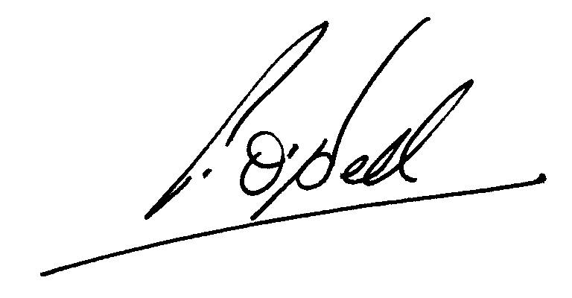

Peter H. O’Dell
Assistant Board Secretary

