February 14, 2004

Ontario Energy Board
P.O. Box 2319
2300 Yonge Street, 26th Floor
Toronto, Ontario, M4P 1E4

Attn: Peter H. O’Dell, Assistant Secretary

Dear Mr. O’Dell:

Re: RP-2004-0020 Consultation re Further Efficiencies in the Electricity Distribution Sector

We are very pleased to note the OEB’s initiative to review further efficiencies in the electricity distribution sector. We also thank the OEB for giving us this opportunity to submit comments on the above subject.

London Hydro is a local electricity distribution company serving approx. 140,000 electricity consumer accounts in the City of London with a population of about 337,000. We have been strong advocates of rationalization of the LDC sector in order to achieve greater benefits for customers and shareholders alike. Our past efforts on this subject have been through our endorsement of the “DEEP” Group report and our direct submission to the Ministry of Energy on August 12, 2002.

In this submission to the OEB, the focus of our comments is on the controllable structural efficiency factor out of the three types of efficiency factors cited in the OEB staff discussion paper – the two other factors being operational efficiencies and uncontrollable structural efficiencies. We are of the opinion that these three factors are inter-related; however, the controllable structural efficiency gains are fundamental to achieving productivity gains in operation and counter the impact of uncontrollable structural efficiencies. This is demonstrably true since the fixed cost component, which is an increasing characteristic of operation of utilities of today, can be spread over a larger number of customers and service territories in cases where controllable structural efficiencies are optimal.

Collectively, Ontario’s distribution companies have commendably met the challenges and successfully managed significant changes to their regulatory and shareholder requirements while continuing to deliver electricity in a reliable manner over the past several years. However, going forward, the business strategies of the remaining 95 electricity distribution companies must have the utmost consideration of achieving cost efficiencies in order to provide improving service levels while maintaining or even reducing the cost of service to customers. Since the introduction of the first generation PBR in 2001, the distribution rates have steadily increased. There are further upward pressures on distribution tariffs to grow. The overall impact of increases in distribution tariffs on total electricity might seem minor,` for the distribution cost accounts 20% on average (18% to 22%) of the total electricity bill. However, going forward, LDCs would collectively fail our customers if we do not first look inside our own industry and achieve efficiencies without jeopardizing the service levels, before considering increases to rates. In our view, there is a strong case to be made to achieve greater efficiency in the controllable structural factor, before embarking to seek a corresponding justifiable rate (revenue) relief.

Controllable structural efficiency improvement can lead to greater savings

In 2002-03 London Hydro undertook an analysis to study the cost savings that could result from amalgamated operations of London Hydro with another smaller LDCs (one-fourth the customer base of London Hydro). The study was conducted jointly and was based upon a “bottom-up” approach, i.e. various teams of employees (departments) were put together to determine the structure of a newly merged operation for their respective area of expertise (functions). In total there were five major teams with several sub-teams to design the new organization and to analyze the cost and efficiency savings over 10 years of merged operations. The five major teams were: Engineering & Operations, Customer Services, Information Systems, Finance and Human Resources/Corporate. The summary results of the analysis were that the merged operations of the two utilities over ten years would (conservatively) result in net nominal savings of about $13M, which represents an NPV of $6.8M at a discount rate of 7%.

Further to this study, we analyzed the savings by including another LDC of similar size to that of London Hydro in the region, which could pave the path to forming a regional distribution company (RDC) in the southwest Ontario. The corresponding net savings over ten years were (again conservatively) found to be $59M in nominal value and about $35M in NPV (discount rate of 7%). These are significant achievable savings based upon the controllable structural efficiency factor alone.

When complete, the study was submitted to an independent third party for review and comment. Overall the consultant not only concurred with the findings of the report, but also specifically commented upon its conservativeness.

Impact of the savings on London consumers and shareholders is significant

For illustrative purposes, we have extracted the relative dollar impact on London Hydro from the study of merging the three utilities in southwest Ontario. The relative dollar impact on the customers and shareholders of London Hydro are shown in Figures 1, 2, and 3 given below. In order to appreciate the value of the controllable structural efficiency achieved in the merged operation of three utilities, we particularly draw attention to the customer impact arising in a standalone operation of London Hydro, with the assumption of full cost recoveries in 2006 and beyond.

This illustration is for London Hydro; the results for merged operations are on an “allocation” basis from the Southwest Hydro project between the three LDCs. In Figures 1, 2, and 3, the corporation (Corp.) impact is measured by annual operating income generated from the operation, and the customer impact is represented by accumulated change in annual revenue starting with the projected annual revenue for 2006.

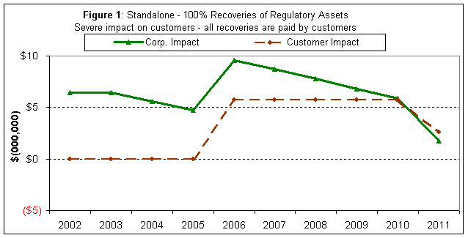

Figure 1 shows that if we do not protect consumers by allowing LDCs to recover 100% of the cost of their regulatory assets, corporations will certainly be protected – albeit at the customers’ expense.

The increases shown in Figure 1 reflect the increase in rates necessary to allow the full commercial return on assets and ii) recovery of regulatory assets over five years from 2006 through 2011. In percentage terms and ignoring other factors, the increase in distribution rates in London would be approximately 14% over the six-year period from 2006 through 2011, and customers would pay an additional $31 million in distribution rates in London alone. Across the province, the estimated customer impact might be between $500 million and $1 billion over 2006-2011.

On the other hand, if no recoveries are permitted and LDCs remain standalone, the corporate value is negatively impacted as shown in Figure 2.

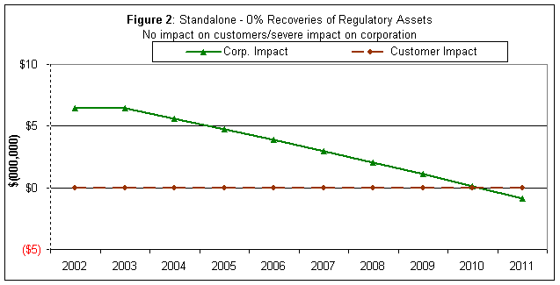

Figure 3 shows that by encouraging amalgamations of LDCs the customer impact can be minimized while providing enough profitability to corporations – essentially the corporate profitability is maintained through savings generated from rationalization. In theory this can result in little or no distribution rate increases for customers in 2006 and subsequent years.

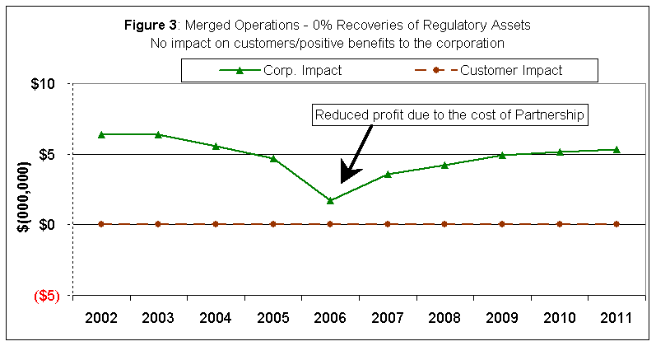
Figure 3 illustrates the benefit of savings from merged operation (vis-à-vis the standalone) under the zero cost recovery. Any incentives by way of allowing cost recoveries for LDCs that merge into larger corporations would further enhance operating income and consequently corporate profitability. To provide increased incentives for LDCs to merge into large corporations, the OEB could consider allowing partial cost recoveries, as shown in Figure 4, a mere 40% of eligible recoveries of regulatory assets would provide healthy earnings to shareholders with a significantly reduced impact on customers.

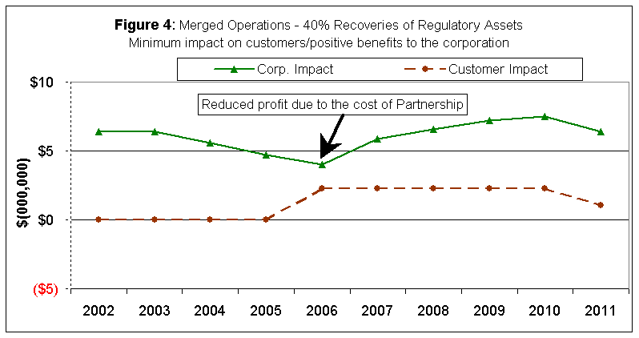

By extension of the logic, if the entire southwest region of Ontario is brought under one regional LDC, including Hydro One’s rural assets (which by the way is not assumed in the Southwest Hydro project), we estimate that the resulting savings would be especially significant, hence eliminating (or at least minimizing) the need for distribution rate increases in 2006 and beyond. Moreover, it will enable the new and larger distribution companies to develop the necessary wherewithal to provide increasing levels of service.

On the basis of our analysis, we are of the opinion that the OEB and the government should seriously consider creating an environment conducive to actively encouraging the consolidation of the operation of utilities across Ontario, where it makes sense. While shared service and cooperative models are other alternatives in lieu of corporate consolidation, their impacts are short lived. In our opinion any efforts short of corporate consolidation leaves the operation of distribution companies in a fragmented state, which will prevent them from achieving an effective resolution of the following challenges.

- Fragmented service territories give rise to complex issues of load transfer, inefficient asset utilization and inconsistent service levels and rates among neighbouring communities.

- Regulators are still left to regulating a large number of utilities, which is burdensome, costly, inconsistent, inefficient and therefore ineffective.

- Ineffectiveness and irrational investment decisions could still be prevalent.

- As mentioned in the OEB staff discussion paper on the referred subject, there are a large number of utilities serving less than 10,000 customers. While these utilities may be able to provide service levels and comply with regulations in some respects, in the future they may be faced with limited or declining resources to constantly deliver on shareholder, customers, and regulators expectations.

In summary, it is sufficient to state that the Ontario electricity distribution sector must work to achieve greater efficiency through rationalization in order to maintain satisfactory rates while enabling itself to provide increasing level of services to customers.

Barriers to Consolidation

The above discussion leads to an obvious question – if the savings identified in the Southwest Hydro project are so significant, (and logically, by extrapolation, even more so, across the Province) why have the shareholders not acted upon it? The answer to this question is not as simple as it may seem. However, in our view, the general barriers to achieving industry consolidation are given below.

- Municipal (public) shareholders value their distribution company assets differently than a private investor. It is worth noting that the public shareholders were entrusted with the LDC assets (did not purchase them), and feel responsible to ratepayers who actually over the years have paid for those assets. The public shareholder does not feel motivated to make decisions like that of a private investor.

- The public shareholder constituents view profits in general as another economic burden and tax grab. Constituents want their LDCs to be strong as it relates to service delivery; however, they also want it to operate as either “not for profit” or at nominal returns. Therefore, the local decision makers might be often hesitant to make an economic based decision.

- Political influences have stalled the process, as no one seems to champion consolidation of the distribution assets, nor are the shareholders willing to risk the political repercussions of favouring the sale of municipal assets. As an example, when the “for sale” issue was previously raised in London publicly in 2000, many interested parties opposed the sale for the fear that the municipality might squander the windfall for short-term benefits rather than looking to the long-term needs of the community.

- Bill 210 and other regulatory requirements have decreased the value of distribution assets and shareholders may be waiting to see if this is short-term before they proceed.

- LDCs have been treated with a soft stick as it relates to non-compliance issues. Although there was forgiveness through the transitional stages of the open market, non-complying LDCs may not see the need to fear any penalty for non-compliance in the future. If they were penalized for not complying, the shareholders might be more motivated to look at other options for delivering local electric services.

- By virtue of introducing the first generation PBR, the OEB might have granted relatively large recoveries of costs without considering the prudence of associated investment decisions of utilities. Such rate approvals forgave past inefficiencies and misled the utilities into becoming complacent.

- The transfer tax is a barrier to private investors.

In its renewed efforts, we propose that the OEB may want to consider the following points in developing a policy to encourage rationalization among LDCs.

- Encourage the rationalization of existing distribution companies into contiguous regional “shoulder-to-shoulder” boundaries based on an economic and political “community of interest” and/or technical/network considerations. The OEB might choose to specify guidelines for LDCs to achieve the above objective.

- The provincial government and the OEB should undertake a concerted communication plan to advise and educate municipal governments on achieving greater efficiencies in management of their respective LDC assets.

- Encourage Hydro One to participate and act as a catalyst to ferment the creation of relatively larger regional distribution companies. Perhaps by taking an equity position in new, regionalized “combined” utilities

- Provide strong incentives to encourage all of the above. These incentives could be in the form of speedy approval and recovery of justifiable cost for those that chose to achieve controllable structural efficiencies, through regional rationalization, and perhaps no adjustments in rates for those that do not undertake to achieve such efficiencies.

London Hydro strongly believes that speedy rationalization of LDCs is the key to the collective success of the electricity distribution sector. The potential savings from rationalization are significant, and we should collectively achieve these savings before looking to cost recoveries at the expense of Ontario consumers.

We recognize that some LDCs with lower costs per customer at present and perhaps with better returns, might not, necessarily share the same enthusiasm for rationalization of the industry. However LDCs with higher unit costs and also having to reckon with uncontrollable structural factors may be quite receptive to increased rationalization. These variances in our opinion are only relevant on a short-term basis and under the guise that the regulator will provide rate relief as and when needed and justified; however, in the long run both LDCs – one with a lower unit cost and the other with higher unit cost – are better off by increasing their respective scale and scope of operation. Furthermore, increasing improvements in controllable structural factors would undeniably enable both positions to acquire increased flexibilities and capabilities to take on an additional role of becoming an LSE and/or DSM provider for the benefit of their consumers.

We appreciate your considerations of the above and please advise if you require further clarifications.

Sincerely,

Bernie Watts Vinay Sharma
CEO, Vice President,
London Hydro Inc. Customer Service & Strategic Planning
Phone: (519) 661-5800 ext. 5535 Phone: (519) 661-5800 x 5404
wattsb@londonhydro.com sharmav@londonhydro.com

Distributors Electricity Efficiency Policy Group “DEEP” is a group of Ontario LDCs committed to leading change in the industry through joint participation of its members.
Southwest Hydro Project
The study was completed before the Government’s announcement regarding the advancement of recovery of regulatory assets in 2004; nonetheless, the significance of the savings achievable through controllable structural efficiency is still relevant.
Escalation factors are not considered in these illustrations.
We do appreciate and understand the OEB’s challenges in managing on timely basis the rate applications of such a large number of LDCs – another reasons to seek immediate rationalization of LDC sector in order to avoid the repeat of this challenge in the future.

