Attachment 3

Connection Process

Prepared by Stakeholders October 2003
Process for Connecting an Embedded Generator
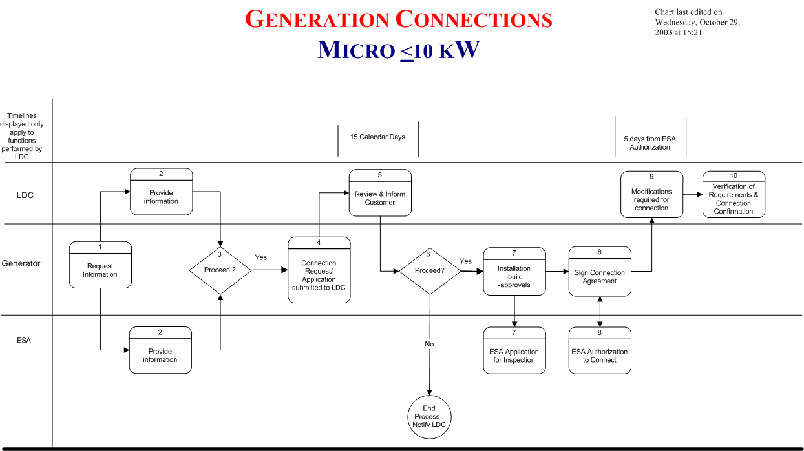

Micro Embedded Generation Connection Process*
10 kW or less - Load Displacement or Emergency Back-up Generation

Step 1. – Request for Information

Customer proposing the installation of a Generation Unit contacts the LDC and ESA for information.

Step 2. – Provision of Information

LDC makes the information available to the proponent in a timely manner. Information Package includes:

- Process (basis is in DSC - this incorporates LDC specifics; timing; contact numbers etc. and reiterates/stresses the need for ESA authorization to connect)
- approvals needed by LDC for connection
- technical requirements including metering
- contractual requirements (Connection Agreement)
- application forms
- informs Generator of potential need to contact OEB

ESA provides information on Electrical Safety Requirements

Step 3. – Proceed (Generator Develops Plan)

Generator reviews relevant information from utility, ESA, on technologies, and puts together an installation plan:

- what size/type of generation
- load displacement/net metering/isolated from utility
- project plan - who needs to be included / when

Step 4. – Application Process

Generator submits application to LDC. Information required includes:

- size of generation(each unit and total at connection point)
- type of generation
- type and details of technology
- location (address, account number)

Step 5. ESA Electrical Inspection Application
Note: runs in parallel with Step 6.

- Generator to submit plans and specific information to ESA for inspection.

Step 6. LDC Review of Application

For Generator at existing customer connection:

- LDC must respond to the Generators application and make an offer to connect approved generation or refusal to connect with reasons within 15 calendar days
- Normal requirement - new meter only
- Check for service upgrade requirement
- Check for significant amount of other generation on feeder.
- Inform Generator of requirements specific to the connection (usually requirements for metering) and costs, timing to implement, etc.
- Offer to connect good for 30 days - generator to indicate intent within this timeframe

Steps 7 & 8 Decision to Proceed and Install

If the Generator decides to proceed the Generator will:

- commit to paying the Distributor for upgrades (metering)
- begin to install
- the Generator must work closely with the utility, the ESA and any other organizations from which work, inspections, approvals or licenses are required to prevent delays .
- These activities will be planned in coordination with project milestones and it is up to the Generator to initiate actions at the required times.
- Generator applies for Electrical Inspection

Steps 9 & 10

The Generator will contact the LDC after completing the ESA inspection process and receiving an Authorization to Connect.
- The LDC will respond within 5 days to change the meter (if necessary)
- The utility will check to ensure Generator commitments have been satisfied. These include:
  - ESA Authorization to Connect
  - Signed Agreement

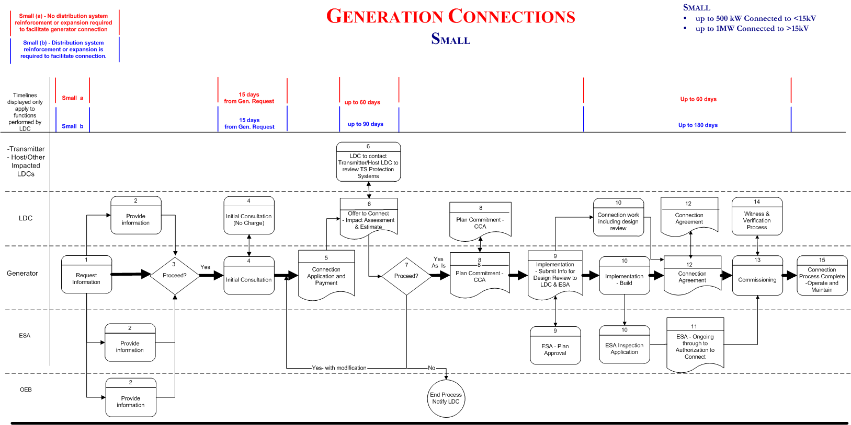
Small Embedded Generation Connection Process
up to 500 kW Connected to <15kV
up to 1MW Connected to >15kV

Note: Small Generation Facilities have been split into two categories A & B.
The Process followed for connection of both A & B is identical, only the timelines will differ.

- Small a - No distribution system reinforcement or expansion required to facilitate generator connection

- Small b - Distribution system reinforcement or expansion is required to facilitate connection.

Note: Where there is mutual agreement, various steps in the process can be combined for the benefit of both parties.

Step 1. – Initial Contact

Customer proposing the installation of a Generation Unit contacts the LDC and ESA for information.

Step 2. – Provision of Information

LDC make the information available to the proponent in a timely manner. Information Package includes:

- Process (basis is in DSC - this incorporates LDC specifics; timing; contact numbers etc. and reiterates/stresses the need for ESA authorization to connect)
- approvals needed by LDC for connection (ESA)
- technical requirements including metering
- contractual requirements (Connection Agreement)
- application forms
- informs Generator of potential need to contact OEB

ESA provides information on Electrical Safety Requirements and their “Plan Approval” Process

Step 3. – Generator Develops Plan

Generator reviews relevant information from utility, ESA, on technologies, and puts together an installation plan:

- what size / type of generation
- load displacement / net metering / isolated from utility
- project plan - who needs to be included / when

Step 4. – Initial Consultation (No Charge)

Generator requests preliminary meeting and submits basic information. Information required includes:

- size of generation(each unit and total at connection point)
- type of generation
- type and details of technology
- location (address, account number)

LDC meets with Generator to review plans at basic level. Basic level feasibility discussed with Generator ie:
- Timing: LDC meets with Generator within (15) days of receipt of basic information and request for meeting.
- Location of existing Distribution facilities in reference to proposed Generation unit.
- Rough estimate on time and costs which could be associated with project.
- Basic feasibility of project

Step 5. – Application for Impact Assessment

Generator applies for Distributor Impact Assessment and makes payment with Application.

Information required includes:

- size of generation(each unit and total at connection point)
- type of generation
- type and details of technology
- fuel type
- single line diagram
- location (address, account number)
- Preliminary Generator / Consultant design of proposed interface protection.

Generator wants to know:
- Connection Feasibility and Cost
- Metering Requirements
- ESA Requirements

Step 6. Offer to Connect (Impact Assessment & ESA Approval Process)

The LDC performs an Impact Assessment of proposed Generation on utility and customers
- Voltage impacts
- Current Loading
- Fault Currents
- Includes connection feasibility and identification of line / equipment upgrades required, distribution or transmission system protection modifications / requirements, metering requirements, and detailed cost estimate.

Timing
- time to review and inform from receipt of payment & application Small a - (up to 60 days)
- time to review and inform from receipt of payment & application Small b - (up to 90 days)

Steps 7 & 8 Decision to Proceed and Install

If the Generator decides to revise the original plans based on results of Impact Assessment, the plans must be re-submitted for another review by going back to step 5. Any change in design, equipment, or plans requires notification to the ESA.

If the Generator feels that the offer to connect is not fair and reasonable, the Generator should request the LDC to review using the Dispute Resolution process as defined in the LDC’s Conditions of Service.

If the Generator decides to proceed:

- both parties sign Connection Cost Agreement
- Commits the Generator to payments
- Commits both parties to schedules, information exchange, scope of work of the generator and of the distributor
- Distributor initiates the work to be done to facilitate the connection
- Generator initiates the required activities
- Generator must work closely with the utility, the ESA and any other organizations from which work, inspections, approvals or licenses are required to prevent delays .

Steps 9 & 10 Implementation

Both Parties Committed to project and Generator commits to obtain required approvals.

- Generator prepares detailed engineering drawings
- Submit all detailed plans to ESA for “Plan Approval” process (includes detailed SLD, Interface Protection)
- submit information to LDC for design review (includes detailed SLD, Interface Protection and Metering details)(Recommend that generator provide this information to LDC within 30 days of signing CCA so that Design Review can be done in a timely manner)

- LDC performs Design Review to ensure detailed engineering is acceptable and informs Generator
- Interface Protection Design Review
- Utility reviews detailed SLD and interface protection to ensure acceptable.
- Recommend that this review be complete before equipment purchase by generator.

- Generator receives Interface Protection Design Review from LDC
- Generator tenders and awards contracts for equipment
- build - including ESA and other approvals
- Connection Work
- line / equipment upgrades are completed

Generator constructs facility and applies for ESA Electrical Inspection to receive “Authorization to Connect”.

Step 11 Authorization to Connect

The Generator arranges for and receives Authorization to Connect from ESA:

Step 12 Connection Agreement

The Generator and the Distributor agree to, and sign Connection Agreement.

Note: A Temporary connection agreement for the purpose of connection for Commissioning and Verification may be signed at this point while negotiating final Connection Agreement.

Step 13 & 14 Commissioning & Verification

Generation Unit Commissioning and Testing.
- The Generator arranges for Commissioning and testing of the Facility
- The LDC witnesses and Verifies the commissioning process

Note:
- Timing: time from commitment to proceed (step 9) to final connection Small a - (60 days)
- Timing: time from commitment to proceed (step 9) to final connection Small b - (180 days)

Step 15 Completion

Process Complete – generation unit fully connected and operational

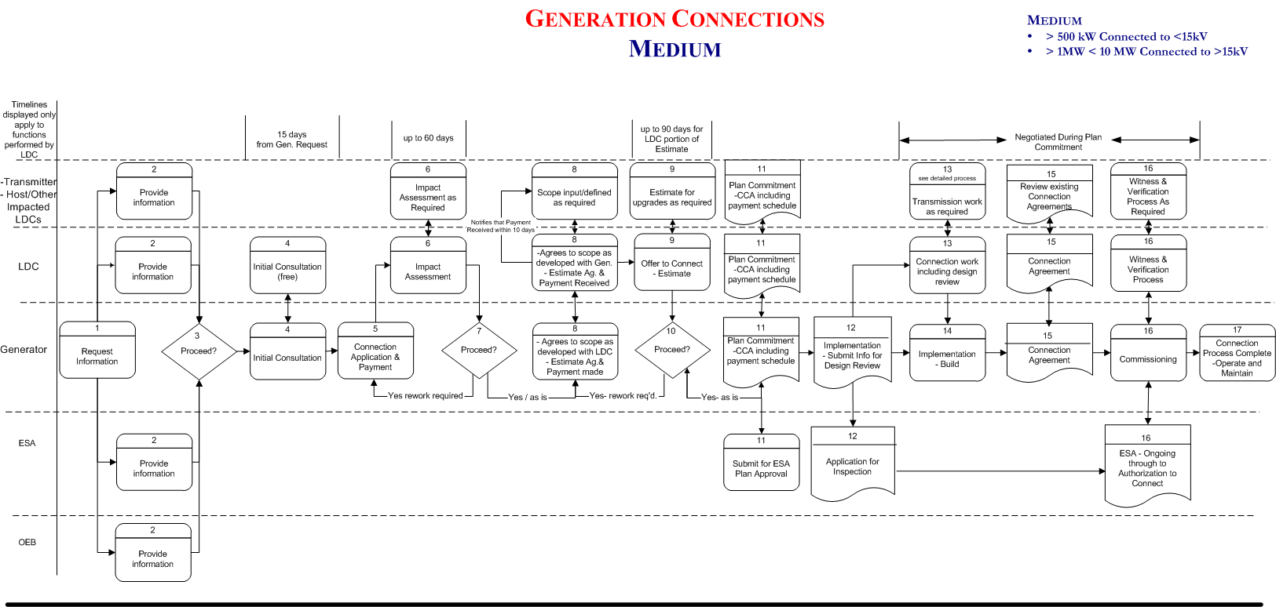
Medium Embedded Generation Connection Process
Greater than 500 kW Connected to <15kV
Greater than 1MW and Less than 10 MW Connected to >15kV

Note: Where there is mutual agreement, various steps in the process can be combined for the benefit of both parties.

Step 1. – Initial Contact

Customer proposing the installation of a Generation Unit contacts the LDC and ESA for information. The LDC may also guide the Generator to contact the Transmitter for additional connection information. Since it is likely that the Generator may be planning on selling power to the grid, the Generator may need to also contact the OEB regarding Licence applications.

Step 2. – Provision of Information

LDC to make the information available to the proponent in a timely manner. Information Package includes:

- Process (basis is in DSC - this incorporates LDC specifics - contact numbers etc. and reiterates/stresses the need for ESA “Plan Approval” and authorization to connect)
- approvals needed by LDC for connection (ESA)
- technical requirements including metering
- contractual requirements (Connection Agreement)
- application forms
- informs Generator of potential need to contact Transmitter and OEB

Step 3. – Generator Develops Plan

Generator reviews relevant information from utility, ESA, Transmitter, and OEB, and puts together a development plan:

- what size/type of generation
- load displacement/net metering/isolated from utility
- project plan - who needs to be included / when

Step 4. – Initial Consultation (No Charge)

Generator requests preliminary meeting and submits basic information. Information required includes:

- size of generation(each unit and total at connection point)
- type of generation
- type and details of technology
- location (address, account number)
- additional information as suggested by Transmitter, ESA, OEB

LDC meets with Generator to review plans at basic level. Basic level feasibility discussed with Generator ie:

- Timing: LDC meets with Generator within (15) days of receipt of basic information and request for meeting.
- Location of existing Distribution facilities in reference to proposed Generation unit.
- Rough estimate on time and costs which could be associated with project.
- Basic feasibility of project

Step 5. – Application for Impact Assessment

Generator applies for Impact Assessment and makes payment with Application. Impact assessment may also be required from Transmitter or Host LDC. The LDC will forward applicable information on behalf of Generator.

Information required includes:

- size of generation(each unit and total at connection point)
- type of generation
- type and details of technology
- fuel type
- single line diagram
- location (address, account number)
- Preliminary Generator / Consultant design of proposed interface protection.

Generator submits initial information to ESA for Inspection or Plan Approval requirements.

Step 6. Impact Assessment

The LDC performs an Impact Assessment of proposed Generation on utility and customers
- Voltage impacts
- Current Loading
- Fault Currents
- Includes connection feasibility and identification of line / equipment upgrades required, distribution or transmission system protection modifications, metering requirements, and an overview of cost implications.

Timing
- time to review and inform from receipt of application - (up to 60 days)

The LDC requests & receives an Impact Assessment of proposed Generation on Transmitter / Host LDC and customers. Transmitter / Host LDC will prepare impact assessment as required. The Geographic LDC is only responsible for timely delivery of information specific to their Distribution System.

Generator wants to know:
- Connection Feasibility and Cost
- Metering Requirements

Assumes Generator / Consultant will design Generation Facility, including interface protection to achieve the required functionality. Utility will review this design within 1 month of signing CCA signing.

Generator also provides information to Inspection to begin Plan Approval process.

Steps 7 & 8 Decision to Proceed and Establish Scope of Project

If the Generator decides to revise the original plans based on results of Impact Assessment, the Generator must re-submit the revised plans for another review by going back to step 5. Any change in design, equipment, or plans requires notification to the ESA.

If the Generator feels that the results of the impact assessment are manageable, the Generator will request a meeting to develop a scope so that the LDC can prepare an estimate and an “Offer to Connect”.

If the Generator decides to proceed:

- both parties agree to and sign scope of project
- Generator Pays for preparation of estimate by LDC, Host Distributor and Transmitter as required

Steps 9, 10, 11 Prepare Estimate & Present Offer to Connect

The LDC must notify the Transmitter and/or Host LDC (as required) within 10 days of receiving payment that the Generator has decided to proceed and an estimate is to be prepared.
The LDC shall prepare a detailed estimate of the project based on the scope defined in step 8.
The LDC must prepare their portion of the Offer to Connect within 90 days of receipt of payment from Generator. In any event, the LDC has up to 30 days from date of receipt to incorporate the estimate of the Transmitter or Host LDC.

If the Generator decides to proceed after reviewing the Offer to Connect:

- all parties agree to and sign Connection Cost Agreement (CCA)
- Generator agrees to payment schedule for work required by LDC and/or Transmitter / Host LDC
- Commits all parties to schedules, information exchange, scope of work
- the Generator must work closely with the utility, the ESA and any other organizations from which work, inspections, approvals or licenses are required to prevent delays .

Steps 11, 12, 13, 14 – Implementation

Timing
- time from commitment to proceed to final connection to be negotiated in Connection Cost Agreement
- Distributor initiates the work to be done to facilitate the connection
- Generator initiates the activities identified as it’s responsibility
- Transmitter and/or Host LDC initiates the work to be done to facilitate connection

Both Parties Committed to project and Generator commits to obtain required approvals.

- Generator prepares detailed engineering drawings
- Submit all detailed plans to ESA for “Plan Approval” process (includes detailed SLD, Interface Protection)
- submit information to LDC for Design Review (includes detailed SLD, Interface Protection and Metering details)(Recommend that generator provide this information to LDC within 30 days of signing CCA so that Design Review can be done in a timely manner)

- LDC performs Design Review to ensure detailed engineering is acceptable and informs Generator
- Interface Protection Design Review
- Utility reviews detailed SLD and interface protection to ensure acceptable.
- Recommend that this review be complete before equipment purchase.

- Generator receives Interface Protection Design Review from LDC
- Generator tenders and awards contracts for equipment
- build - including ESA and other approvals
- Connection Work
- line / equipment upgrades are completed

Generator constructs facility and applies for ESA Electrical Inspection to receive “Authorization to Connect”.

Step 15 - Connection Agreement

The Generator and the Distributor agree to, and sign Connection Agreement.
LDC and Transmitter / Host LDC review existing agreements for required revisions.

Note: A Temporary connection agreement for the purpose of connection for Commissioning and Verification may be signed at this point while negotiating final Connection Agreement.

Step 16 Commissioning & Verification

Generation Unit Commissioning and Testing.
- The Generator arranges for Commissioning and testing of the Facility
- The LDC witnesses and Verifies the commissioning process
- The Transmitter/Host LDC witness and Verify the commissioning process as required.

Step 17 Completion

Process Complete – generation unit fully connected and operational

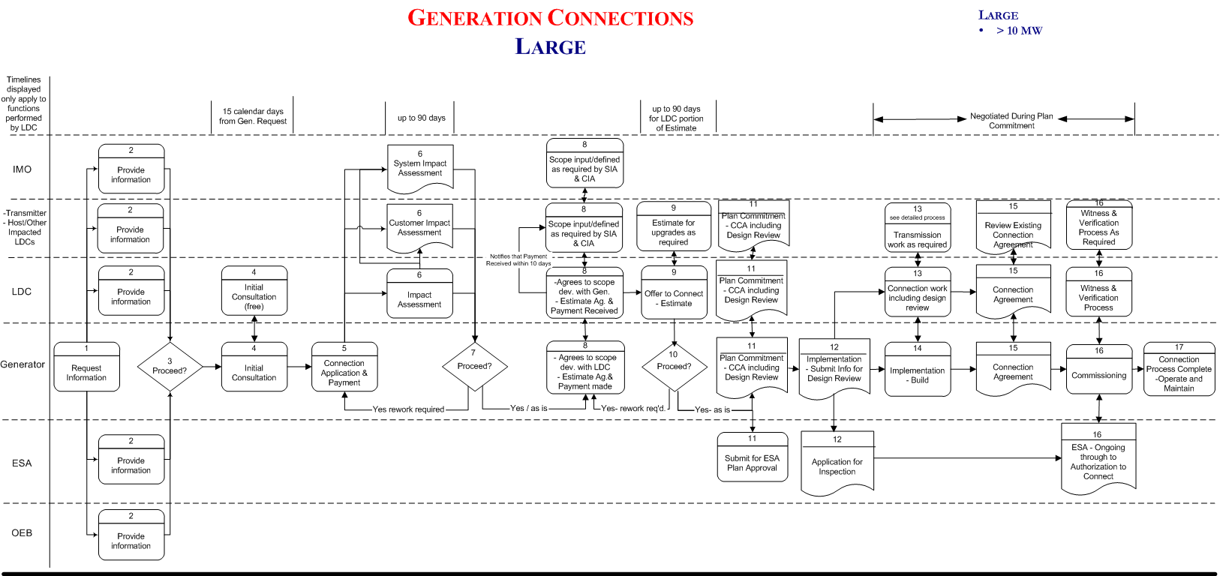
Large Embedded Generation Connection Process
Greater than 10 MW

Note: Where there is mutual agreement, various steps in the process can be combined for the benefit of both parties.

Step 1. – Initial Contact

Customer proposing the installation of a Generation Unit contacts the LDC and ESA for information. The LDC may also guide the Generator to contact the Transmitter for additional connection information. The LDC should inform the Generator that IMO involvement is required for all projects over 10 MW. Since it is likely that the Generator may be planning on selling power to the grid, the Generator may need to also contact the OEB regarding Licence applications.

Step 2. – Provision of Information

LDC to make the information available to the proponent in a timely manner. Information Package includes:

- Process (basis is in DSC - this incorporates LDC specifics - contact numbers etc. and reiterates/stresses the need for ESA authorization to connect)
- approvals needed by LDC for connection (ESA)
- technical requirements including metering
- contractual requirements (Connection Agreement)
- application forms
- informs Generator of need to contact Transmitter, IMO, and OEB

Step 3. – Generator Develops Plan

Generator reviews relevant information from utility, ESA, Transmitter, IMO, and OEB, and puts together an installation plan:

- what size/type of generation
- load displacement / isolated from utility / grid connection
- project plan - who needs to be included / when

Step 4. – Initial Consultation (No Charge)

Generator requests preliminary meeting and submits basic information. Information required includes:

- size of generation(each unit and total at connection point)
- type of generation
- type and details of technology
- location (address, account number)
- additional information as suggested by Transmitter, ESA, OEB

LDC meets with Generator to review plans at basic level. Basic level feasibility discussed with Generator ie:

- Timing: LDC meets with Generator within (15) days of receipt of basic information and request for meeting.
- Location of existing Distribution / Transmission facilities in reference to proposed Generation unit.
- Rough estimate on time and costs which could be associated with project.
- Basic feasibility of project

Step 5. – Application for Impact Assessment

Generator applies for Impact Assessment and makes payment with Application. Impact assessment may also be required from Transmitter and/or Host Distributor. Projects greater than 10MW will also require a System Impact Assessment by the IMO. The LDC will collect payment from Generator and forward both payments and applicable information on behalf of Generator to Transmitter, Host Distributor, and IMO as required.

Information required includes:

- size of generation(each unit and total at connection point)
- type of generation
- type and details of technology
- fuel type
- single line diagram
- location (address, account number)
- Preliminary Generator / Consultant design of proposed interface protection.

Step 6. Impact Assessment

The LDC performs an Impact Assessment of proposed Generation on utility and customers
- Voltage impacts
- Current Loading
- Fault Currents
- Includes connection feasibility and identification of line / equipment upgrades required, distribution or transmission system protection modifications, etc.

Timing
- time to review and inform from receipt of application - (up to 90 days)

The LDC requests & receives an Impact Assessment of proposed Generation on Transmitter, Host LDC, and customers. Transmitter / Host LDC will prepare impact assessment as required. The Geographic LDC is only responsible for timely delivery of information specific to their Distribution System.

Generator wants to know:
- Connection Feasibility and Cost
- Metering Requirements
- ESA Requirements

Assumes Generator / Consultant will design Generation Facility, including interface protection to achieve the required functionality. Utility will review this design within 1 month of signing CCA signing.

Generator also Provides information to Inspection to begin Plan Approval process.

Steps 7 & 8 Decision to Proceed and Establish Scope of Project

If the Generator decides to revise the original plans based on results of Impact Assessment, the Generator must re-submit the revised plans for another review by going back to step 5. Any change in design, equipment, or plans requires notification to the ESA.

If the Generator feels that the results of the impact assessment are manageable, the Generator will request a meeting to develop a scope so that the LDC can prepare an estimate and an Offer to Connect.

If the Generator decides to proceed:

- both parties agree to and sign scope of project
- Generator Pays for preparation of estimate by LDC, Host Distributor, Transmitter and IMO as required

Steps 9, 10, 11 Prepare Estimate & Present Offer to Connect

The LDC must notify the Transmitter and/or Host LDC (as required) within 10 days of receiving payment that the Generator has decided to proceed and an estimate is to be prepared.
The LDC shall prepare a detailed estimate of the project based on the scope defined in step 8.
The LDC must prepare their portion of the Offer to Connect within 90 days of receipt of payment from Generator. In any event, the LDC has up to 30 days from date of receipt to incorporate the estimate of the Transmitter or Host LDC.

If the Generator decides to proceed after reviewing the Offer to Connect:

- all parties agree to and sign Connection Cost Agreement (CCA)
- Generator agrees to payment schedule for work required by LDC and/or Transmitter / Host LDC or IMO
- Commits all parties to schedules, information exchange, scope of work
- the Generator must work closely with the utility, the ESA and any other organizations from which work, inspections, approvals or licenses are required to prevent delays .

Steps 11, 12, 13, 14 - Implementation

Timing
- time from commitment to proceed to final connection to be negotiated in Connection Cost Agreement
- Distributor initiates the work to be done to facilitate the connection
- Generator initiates the activities identified as its’ responsibility
- Transmitter / Host LDC / IMO initiates the work to be done to facilitate connection

Both Parties Committed to project and Generator commits to obtain required approvals.

- Generator prepares detailed engineering drawings
- Submit all detailed plans to ESA for “Plan Approval” process (includes detailed SLD, Interface Protection)
- submit information to LDC for Design Review (includes detailed SLD, Interface Protection and Metering details)(Recommend that generator provide this information to LDC within 30 days of signing CCA so that Design Review can be done in a timely manner)

- LDC performs Design Review to ensure detailed engineering is acceptable and informs Generator
- Interface Protection Design Review
- Utility reviews detailed SLD and interface protection to ensure acceptable.
- Recommend that this review be complete before equipment purchase.

- Generator receives Interface Protection Design Review from LDC
- Generator tenders and awards contracts for equipment
- build - including ESA and other approvals
- Connection Work
- line / equipment upgrades are completed

Generator constructs facility and applies for ESA Electrical Inspection to receive “Authorization to Connect”.

Step 15 - Connection Agreement

The Generator and the Distributor agree to , and sign Connection Agreement.
LDC and Transmitter / Host LDC review existing agreements for required revisions.

Note: A Temporary connection agreement for the purpose of connection for Commissioning and Verification may be signed at this point while negotiating final Connection Agreement.

Step 16 Commissioning & Verification

Generation Unit Commissioning and Testing.
- The Generator arranges for Commissioning and testing of the Facility
- The LDC witnesses and Verifies the commissioning process
- The Transmitter / Host LDC / IMO witness and Verify the commissioning process as required.

Step 17 Completion

Process Complete – generation unit fully connected and operational

